Technical Design Document for Case Management System

Solution Details

Property | Value
Solution Name | Case Management System
Unique Name | CaseManagementSystem
Description | No description provided.
Solution Type | Unmanaged
Version | 1.0.0.2

Solution Diagram

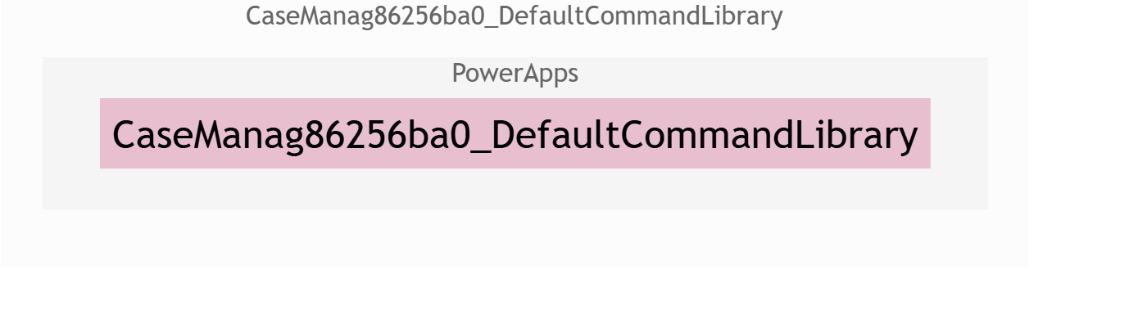

Data and Security

Tables

Table Name | Description | Fields
Case | This table contains records of case information | - crf16_casedescription  - crf16_caseid  - crf16_casemanagerid  - crf16_casetitle  - crf16_clientid  - crf16_enddate  - crf16_startdate  - crf16_totaltimespent  - mscsu_businessimpact  - mscsu_casepriority  - mscsu_casestatus  - mscsu_partyconcerning  - mscsu_totalopentime  - new_assignedto  - new_casenumber  - new_overdue  - new_sladuedate  - new_summary
Case Manager | This table contains records of case manager information | - crf16_casemanagerid  - crf16_department  - crf16_email  - crf16_name  - crf16_phonenumber
Case Task | This table contains records of tasks related to cases | - crf16_assignedto  - crf16_caseid  - crf16_casetask1  - crf16_casetaskid  - crf16_duedate  - crf16_taskdescription  - crf16_taskstatus  - crf16_timespent
Client | This table contains records of client information | - crf16_address  - crf16_clientid  - crf16_email  - crf16_name  - crf16_phonenumber
Communication | This table contains records of communications related to cases | - crf16_caseid  - crf16_casemanagerid  - crf16_clientid  - crf16_communication1  - crf16_communicationid  - crf16_message  - crf16_timestamp
Document | This table contains records of documents related to cases | - crf16_caseid  - crf16_clientid  - crf16_documentid  - crf16_documentname  - crf16_documenttype  - crf16_uploaddate
Time Log | This table contains records of time logs related to cases | - crf16_caseid  - crf16_casemanagerid  - crf16_description  - crf16_hoursspent  - crf16_logdate  - crf16_timelog1  - crf16_timelogid
Unnamed Table

Entity Relationship Diagram

